**MDR Specifications:**

**SPECIFICATION**

**A. Sample Volume :** Approximately 5 Cm3

**B. Oscillating Disk Frequency:** 100 cycles/min. (1.66 Hz)

**C. Oscillating Amplitude :**  + .50, 30, 50 (Half Cycle)

**D. Temperature Control :** Microprocessor Controlled Calibrated Range: 100-2000C Independent Upper& Lower Platen Control

**E. Temp. (Sensor) :** PT-100, Platinum Resistant

**F. Torque Transducer :** Directly shaft mounted in line with Oscillating Disk (Reaction Torque Sensor).

**G. Recording & Display :** Directly On-Line Display on VGA Monitor

**H. Printed Data :** Colour Inkjet Printer

**I. Main Power Supply :** AC 175-275 V, 50 Hz, 20 Amp. max.

**J. Compressed Air :** 60 psi (4.2 Kg./Sq. Cm.) minimum.

Operating pressure controlled by Integral

Regulator with Gauge.

**K. Environment :** Free from Dust & Humidity.

**Moving Die Rheometer**

**Introduction**

Moving Die Rheometer (MDR) is testing equipment which analyses the cure characteristics of Rubber Compound & monitors the processing characteristics as well as physical properties of the material. It is based upon international technology.

It is the only instrument in the rubber industry which helps to choose right ingredients and its appropriate dose to meet the end products Moving Die Rhemoter is a Rotor less Instrument in which Die oscillate and measures the change in stiffness of rubber compound, compressed between two heated dies. MDR generates 3 curves S’, S” and tan delta.

The MDR produces a cure curve labeled S’ which is similar to the ODR

curve.

**Definition of S’ and S”**

S’ is called the storage modules, elastic modules or in-phase modules. S” is called the loss modules, viscous modules, or out-of-phase modules. All of these terms hare been used to mean the same thing. The units of S’ and S” in the product family instruments are in-lbs. these are units of torque. They can also be in dNm which are also torque units. These are scientific instruments on the market which also provide a storage and loss modulus but they use the label G’ and G” or E’ and E”. The letter G is used to refer to the shear modulus if a material in modulus units such as Pascal’s or pounds per square inch. The letter E refers to the tensile modulus.

These modules are material constants. There are formulas which have been derived to predict the expected resistance to deformation as a function of strain for different material shapes. That means that if G’ and G” are known then if the equation of a particular sample shape is derived, then the torque can be predicted.

**Source of S’ and S”**

The ability of a metal spring to resist deformation is proportional to how much it is deformed. The more a spring is deformed, the more it pushes back. Rubber has a component which behaves in much the same way. For example, a rubber ball will bounce higher when it is dropped a greater distance. This is true because when it strikes the earth with greater speed (from the greater distance) it is deformed more resulting in the storage of more energy. the resistance to deformation is proportional to S’ or the storage modulus.

However, rubber is a much more complicated material than an elastic spring. If a rubber ball is dropped and allowed to bounce on its own, each bounce will be lower than the preceding bounce. This indicates the presence of a viscous or loss component in the rubber in addition to an elastic component. This is way rubber is often called a viscoelastic material. In order to understand this viscous component it is important to understand this behavior of materials which contain no elastic component such as water. If you place your hand into a still pool of water and hold it perfectly still your hand will feel no force from the water. If you now try to move your hand, you will feel resistance from the water. In fact, the faster you try to move your hand, the more resistance you will feel.

Water represents a purely viscous material. A measure of the magnitude of the resistance to motion is called viscosity. S” represents of the viscous component in rubber.

**Measurement of S’ and S”**

S’ is measured as the torque at maximum displacement (for 1 degree of oscillation this is the normal + or - 1 degree of arc). At maximum displacement, the oscillating rotor or die stops for an instant while it is reversing directions. It is the equivalent of pushing on a spring and holding it in a displaced position while measuring the resistance of that pring to the deformation. S” is measured as the torque at zero displacement or exactly midway between the two maximum displacement positions. At this point the die in the Moving Die Rheometer has no displacement (at the zero position) but is moving at the maximum velocity. When there is zero displacement, any measurable torque is due to the viscous component or S”.

In order to measure S’ and S” in the Moving Die Rheometer, the instrument must first be calibration with the torsion spring torque standard. The torsion spring contains negligible viscous component compared to any rubber. The Moving Die Rheometer assumes that the value for the S” in the spring the zero and that all torque is due to the S’. during calibration, the computer in the Moving Die Rheometer determines factors which are used to correct for any errors in the magnitudes of S’ and S” for the torque standard. The S’ and S” for a rubber sample are then determined based on the torque standard readings.

**Tan (Delta)**

The Tan (Delta) is computed from the ratio S”/S’ or loss of modules divided by the storage modulus. Note that Tan (Delta) does not represent a third torque reading from the Moving Die Rheometer. There are only two unique signals in the Moving Die Rheometer which are S’ and S”. the smaller the Tan (Delta), than the more viscous the material. The Tan (Delta) in the Moving Die Rheometer is the only output which can be related directly to other instruments because it is unit less and is a material property. This does not mean though that a good correlation can be expected. Tan (Delta) is very sensitive to the methods used in the testing.

**Application of S”**

There have been many research articles which discuss the benefits of using S” (loss modules) or Tan (Delta). A relationship may exist between dynamic properties and process ability (eg. Die swell) of uncured compound. After cure, the loss modulus can indicate whether a compound will meet some special application. For example, the rubber use in an automotive engine mount should have a high Tan (Delta) or S” in order to dampen vibrations. On the other hand, the compound used in a rubber band needs a low Tan (Delta) or S” in order to simulate an elastic spring. Other items which influence the Tan (Delta) and loss modulus are: carbon black (type and quantity), molecular weight of polymer, and processing aids.

In the application of S”, it is most important that the user determine whether the information coming from the Moving Die Rheometer is of benefit to him. Many specific areas which are not easily transferable. Even slight deviations from these particular applications may not produce the same success. The user should always make the final judgment.

RESULTS VARIATION:

As per “Rubber World” 1990 January article “New Rheometer and Money Technology” by Patrik J.DiMauro, Monsanto Company, and J. Derudder and J.P.Etienne, Monsanto-Europe, one can appreciate that the results variation between original model and later models is quite substantial especially the times values. This is purely because of better temperature control and recovery Tests conducted on a SBR compound at 177 C in 50 new machines of each type i.e. ODR and MDR, the difference can be summarized as follows:

1. Torque Values:

ML is lower in ODR 2000 then R100S, MH is slightly higher in ODR 2000 then R100S. ML & MH are much lower in MDR due to different design of machine and the dies.

2. Time Values:

Time values are faster in MDR then ODR

3. Sensitivity:

The sensitivity of the machines with respect to variation in ingredient was also assessed and it was found that the difference between R-100S, ODR and MDR was insignificant. Any difference noticed was purely due to better temperature control and recovery.

REDUCED OPERATOR TIME:

* In MDR Directly heated dies reduce testing time and allow 25-

50% more tests than conventional ODR

* Easy sample removal from the die.

* Self-calibrating temperature setting.

OPERATION:

Moving Die Rheometer (MDR) measures the cure characteristics of compounded rubber by using a sealed rotor less moving die system. At the start of a test sample is loaded between the heated dies which are closed pneumatically after the protective shield has been automatically lowered. The lower die is then oscillated through a preset angle (0.5 C). The lower die oscillates at 1.66 HZ. The reaction torque measurement system of the MDR eliminates mechanical friction to provide precise values for elastic modulus S’ (torque) and viscous modulus S”. The reaction torque transducer measures the torque through the sample from the lower die.

The signal of force (torque) is sensed by the sensor, converted volts and then through ADC fed into the computer to draw torque against time cure. The Moving Die Rheometer sealed, rotor less, moving die system has improved capability to detect compound differences. It minimizes the sample slippage at high strains as compared with unsealed system.

APPLICATION AND INFORMATION AVAILABLE

* Elastic Modulus S’ * Viscous Modulus S”

* Tan Delta * Cure Rate

* Tan Delta@ ML * Tan Delta@ MH

* Ts1, Ts2, Ts5, Tc10, Tc50, Tc 90 * OC,End Temp

Trend,Reversion,

* Display of S’, S” along with Tan Delta

* Computer Controlled Automated testing.

* Repeatability-Continuous repeated testing

* On line display of Torque vs. time graph

* Statically Computation of Data

Moving Die Rheometer produces a rheograph from which you can monitor processing and vulcanization characteristics as well as the physical properties of the material being tested. Typically a rheo graph may be divided into three regions.

1) Processing

2) Curing

3) Physical Properties

TROUBLE SHOOTING

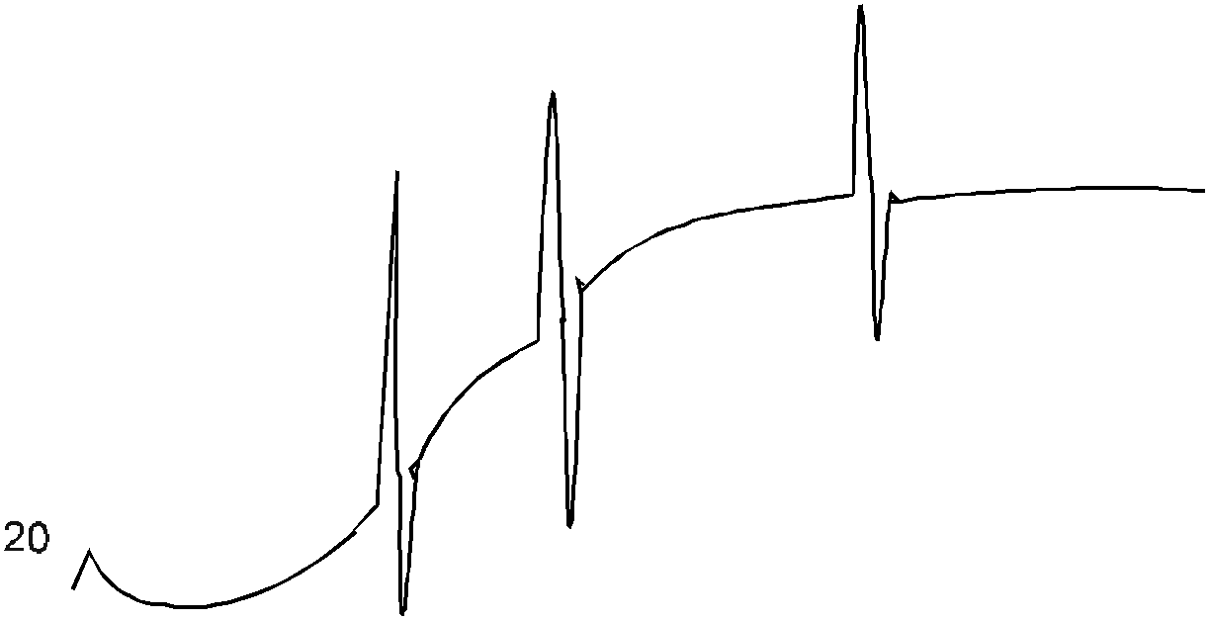

SYMPTOM

-------------

1. Large positive and negative spikes at random spots on curve.

DIAGNOSES

--------------

1. Faulty torque arm requires replacement.

SYMPTOM

-----------

1. Drift from true curve near maximum value.

DIAGNOS

1. Large positive and negative spikes at random spots on curve.

DIAGNOSES

1. Faulty torque arm requires replacement.

2. Drift from true curve near maximum value.

DIAGNOSES

1 Air pressure incorrect.(Correct air pressure)

2. Dirty dies require cleaning.

GENERAL INFORMATION

AIR CYLINDER

PNENUMATIC RAM

UPPER PLATEN UPPER DIE

LOWER PLATEN LOWER DIE

PROXIMITY BOLT

ELECTRICAL HEATER (220 V, 50 Hz.)

ELECTRICAL HEATER (220 V, 50 Hz.)

HOUSING BEARING

TORQUE SHAFT

PROXIMITY

LINK ARM

ALLEN BOLT(SHOLDER BOLT)

LOAD CELL

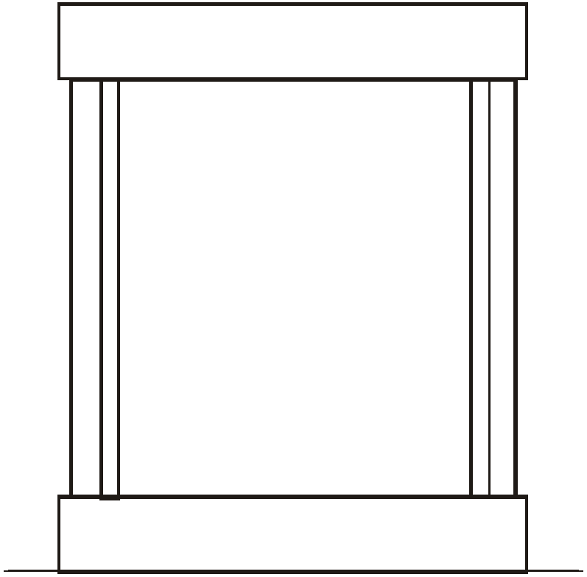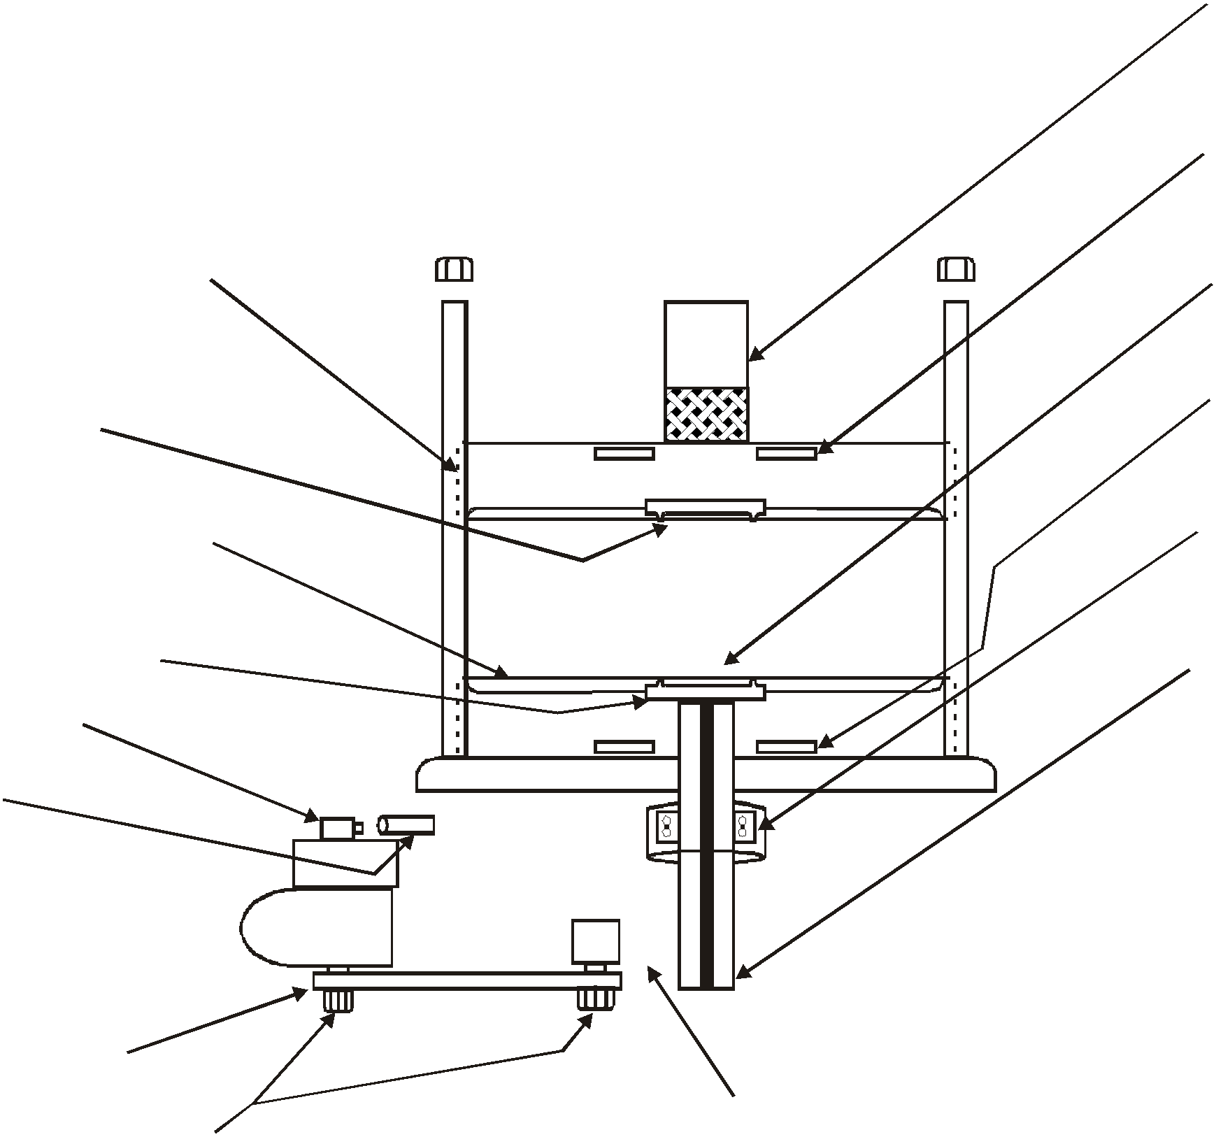

Moving Die Rheometer



**MAIN UNIT :**

The Main Unit is having two portions - Top Portion & Bottom Portion.

***Top Portion*** has two round plates : Upper & the lower plates are interconnected with three studs. This structure is installed on the main base plate. The bottom platen is firmly seated on the lower round plate and the top platen is suspended above the bottom platen by the piston of the main pneumatic cylinder mounted on the top of the upper round plate.

**The Bottom Portion** has three components viz. Bottom Half of the Machine, Sensor & Controlling Unit, Electrical unit. The Sensing and Controlling unit includes Torque Sensors, temperature indicator and controller & the temp. Signal converter. The top sensor is the internal part of the Torque Shaft . Both the temperature controller for respective upper

and lower platen is mounted on the front panel.

**Main Unit Connections :**

1. Power Indicator

2. Shield

3. Die

4. Motor

5. Heater Upper

6. Heater Lower

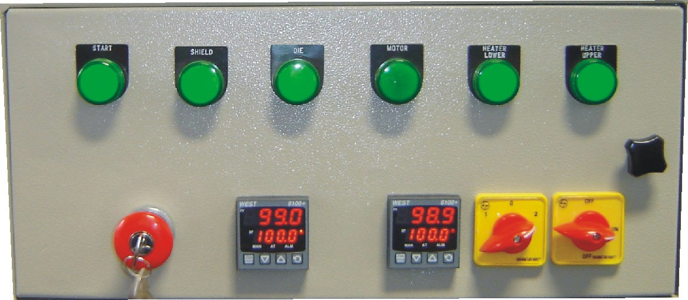

**OPERATION:**

**FRONT CONTROLS:**

Refer to appropriate Figures for the location of each control which will be used in the normal operation and calibration of the instrument. The function

of each control should be understood by referring to the following table before

attempting to operate the instrument. 6

1

2 3 4 5

Standard Basic unit Controls

|  |  |  |
| --- | --- | --- |
| **No.** | **Control or Device** | **Function** |
| 1. | Power Switch | Applies primary power to rheometer. |
| 2.  S | Upper Temperature election Station | Push button selection of any temperature between 0 to 200 of Upper platen. |
| 3.  S | Lower Temperature election Station | Push button selection of any temperature between 0 to 200 of lower platen. |
| 4. A | Auto-Manual Switch | Supplies power through Auto Relay to controller. In Main position only shield will come down. In this position software don’t work. |
| 5. | Heater Power Switch | Supplies power to the heaters “ON”. |
| 6. | Indicators | There are Six indicators. All having their own description. |

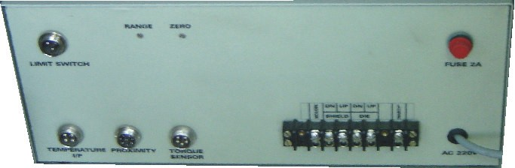

**CONTROLLER (HARDWARE)**

Refer to appropriate Figures for the location of each control which will be used in the normal operation and calibration of the instrument. The function of each control should be understood by referring to the following table before attempting to operate the instrument.

8

1 7

6

2 3 4 5

Controller Main Panel

|  |  |  |  |
| --- | --- | --- | --- |
| **No.** | **Control or Device** | **Function** |  |
| 1. | Limit Switch Connector | Connection for Limit Switch interconnecting cable from basic unit |
| 2. | Temperature Connector | Connection for Temperature Connector interconnecting cable from basic unit |
| 3. | Proximity Connector | Connection for Proximity Connector interconnecting cable from basic unit |
| 4. | Torque Sensor Connector | Connection for Sensor Connector interconnecting cable from basic unit |
| 5. | Main Wire Connector | Connection for all main power of dies, shield, Motor, Main power etc. interconnecting cable from basic unit |  |
| 6. | Main Power | Its a Main power cable which is connected to the main  220 Volts main power |
| 7. | Fuse | A Fuse of 220 Volts for protecting from shock of light. |

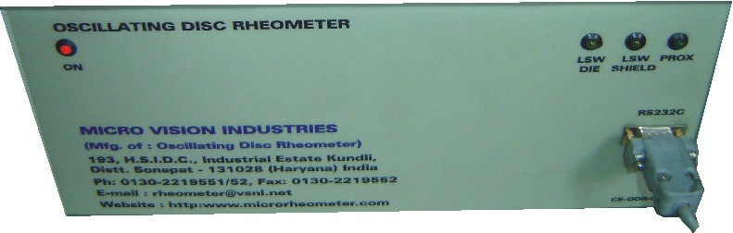

|  |  |  |
| --- | --- | --- |
| **No.** | **Control or Device** | **Function** |
| 8. | Range & Zero | These are only use for the calibration. |

1 2 3 4

Controller Front Panel

|  |  |  |
| --- | --- | --- |
| **No.** | **Control or Device** | **Function** |
| 1. | Main Indicator | This indicator is for Main power. |
| 2. | LSW Die | This indicator is working when the Dies are closed. |
| 3. | LSW Shield | This indicator is working when the Shield is down. |
| 4. | Proximity | This indicator is blinking when the motors round is complete. |
| 5. | RS 232 Connector | This connector is only connected to the computer. |

MDR Testing Procedure

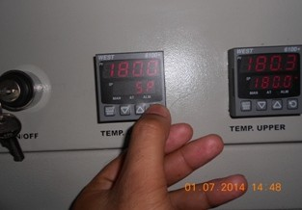

1. Switch on the machine as show below

.

2. Set reqire Temperature as show below

after 15-20 minutes set temperature will be reach set point

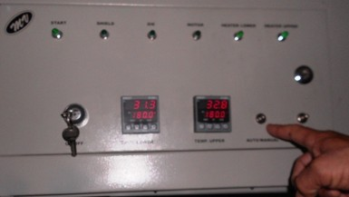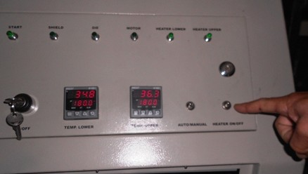

3. Select Auto / Manual switch is auto position as show below

.

4. Select heater switch is on position as show below

**I/O’S**

**Inputs:**

1. Load cell/torque sensor : 1No.
2. Solenoid valve 230v AC : 2 Nos.
3. Heater 500w/2Amps Max : 2 Nos.

**Outputs:**

1. RS-232 bidirectional
2. Indication when dies are closed
3. Indication when shield is down

**I/O’S To Start TEST:**

|  |  |  |  |
| --- | --- | --- | --- |
| Input Field Name | Sample Value | Data Type | Unit |
| Max. Torque | 133.00 | float 64bit | N |
| Test. Max.Temp | 160.00 | float 64bit | Degree Celsius |
| Test Max Time | 90.00 | float 64bit | Minute |
| Arc | 0.50 | float 64bit | mm |
|  |  |  |  |
|  |  |  |  |
|  |  |  |  |

